8.1. Data Flow Diagram Level-1
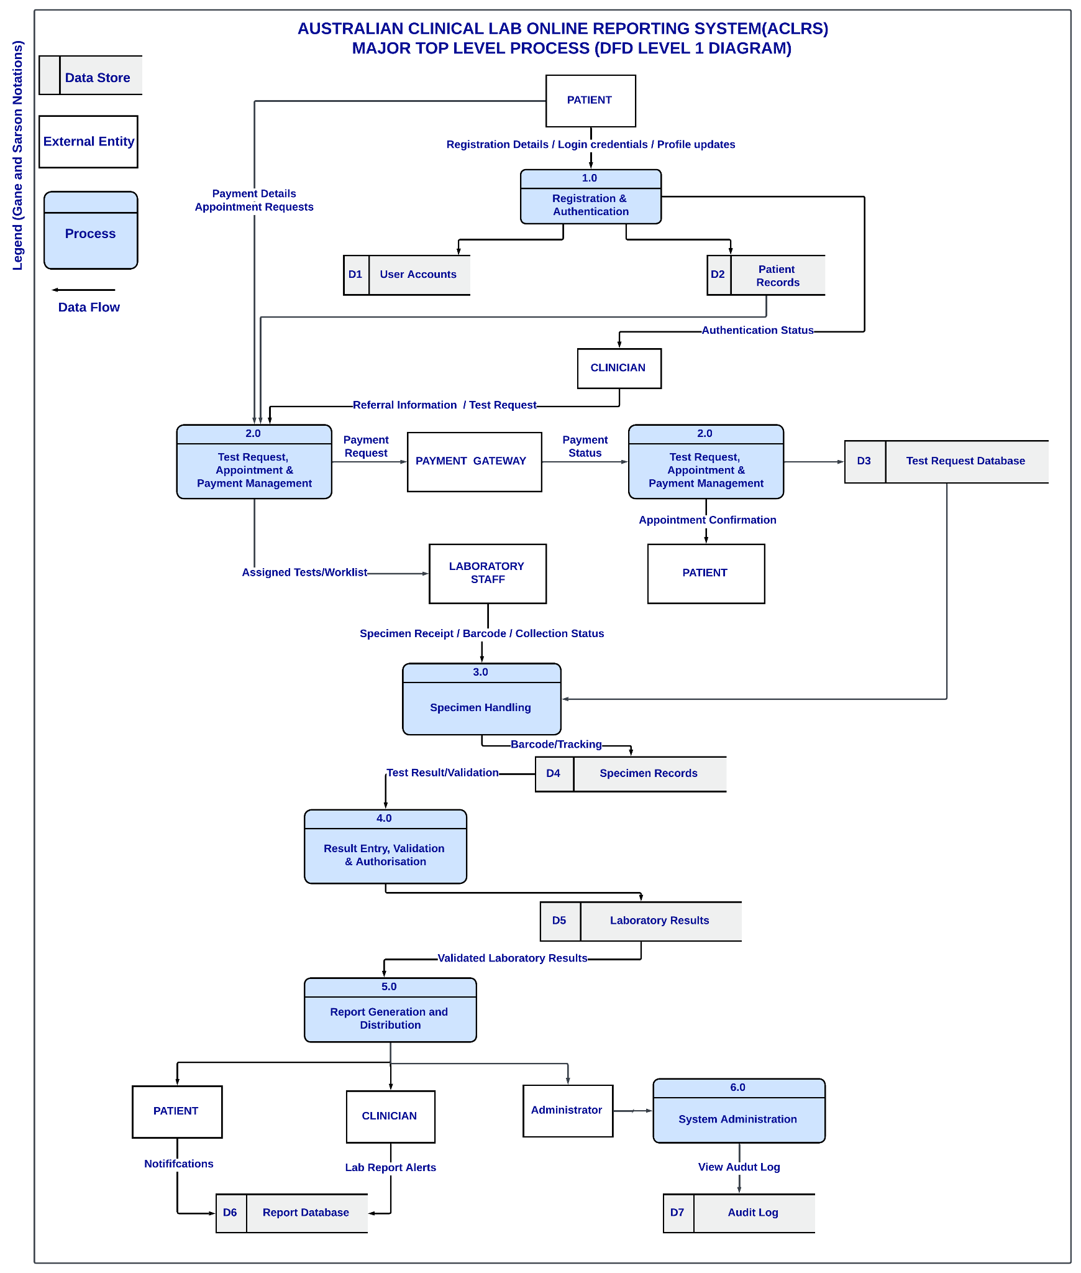
Fig: Australian Clinical Lab Online Reporting System Level-1 Data Flow Diagram

External Entities

- Patient
- Clinician
- Laboratory Staff
- Administrator
- Payment Gateway

Processes

- 1.0 Registration & Authentication: It involves patients entering registration details and updating their profiles which are stored in D1-User Accounts and D2- Patient Records.

- 2.0 Test Request Management: The process begins with the patient sending appointment requests and payment details. The clinician then submits “Referral information” and “ Test requests”.The system then communicates with payment gateway for payment processing and returning payment status. After successful payment, the test request is saved in D3- Test Request Database and the worklist is handed out to the lab staff.

- 3.0 Specimen Handling: In this process, the specimen is picked up by the laboratory staff and the information such as specimen received, barcode and collection status is updated. All this information is entered on the specimen records -D4 and is tracked by using the barcode before the specimen is sent for the tests.

- 4.0 Result Management: It involves laboratory staff entering, validating and authorizing test requests and storing it in Laboratory results- D5.

- 5.0 Report Generation and Distribution:The system fetches validated laboratory results from D5, produces the final report, sends it to the patient and the clinician. The Administrator can access notifications and reports in the D6-Report Database..

- 6.0 System Administrations: The administration module is available for administrators to access and D7- Audit Log shows recorded activities, which track activities in the system.

Data Storage

- D1- User Accounts
- D2 -Patient Records
- D3 -Test Request Database
- D4 -Specimen File
- D5 -Result File
- D6 -Report Database
- D7- Audit Logs

